To the Staff at Tots Corner,

We observed so many big ideas with all our senses at Tots Corner! In particular, we were struck by how much evidence we saw of how you view children as competent and capable:

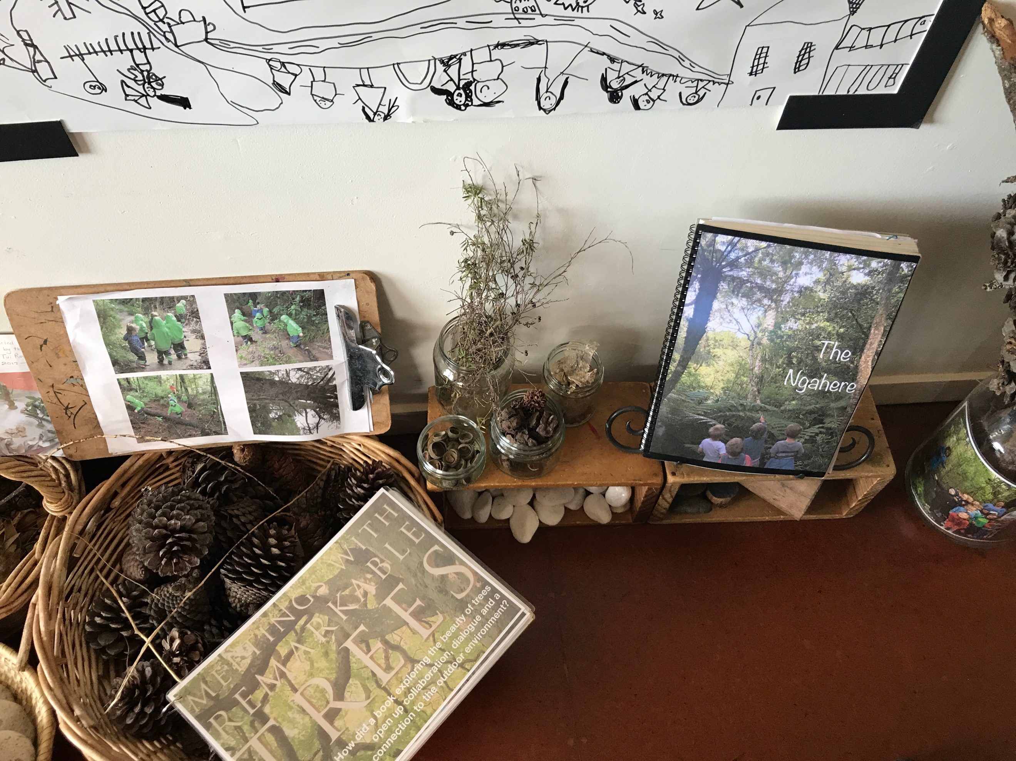
In the documentation of the investigation of the Ngahere: We loved how you kept rough notes of children’s thinking, as well as notes from electronic communication. We noticed evidence of teachers and children thinking together, which echoed Bridgette’s presentation on the meaning of “pedagogy” – walking together on a learning journey. You captured the learning process in a very organic, evolving way: the documentation wasn’t perfect or finished, but it was bound in a book and honored as a valuable object all the same.

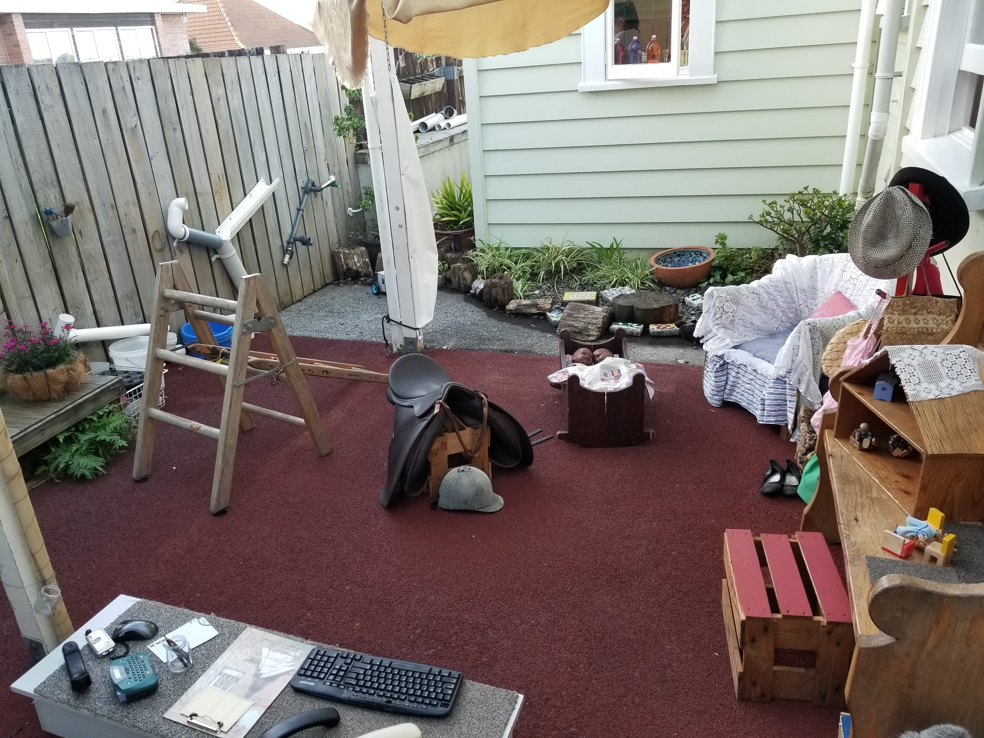
In the saddle and vaulting project: We were struck by the story of how observing a child’s play with a toy horse inspired a long-term investigation into saddles, horses, riding and vaulting, where children were encouraged to take physical and cognitive risks.

In the fabric exploration in the nest: We saw how seeking the child’s point of view helped you find the details of children’s competency that capture your heart and mind. Teacher Emma’s own art background seemed to have inspired her to stretch her own limits and challenged her to find new ways of exploring materials with the infants. This seemed to us a powerful example of trusting children to manipulate materials in unexpected ways, to construct their own meaning about and use of materials and to take physical risks.
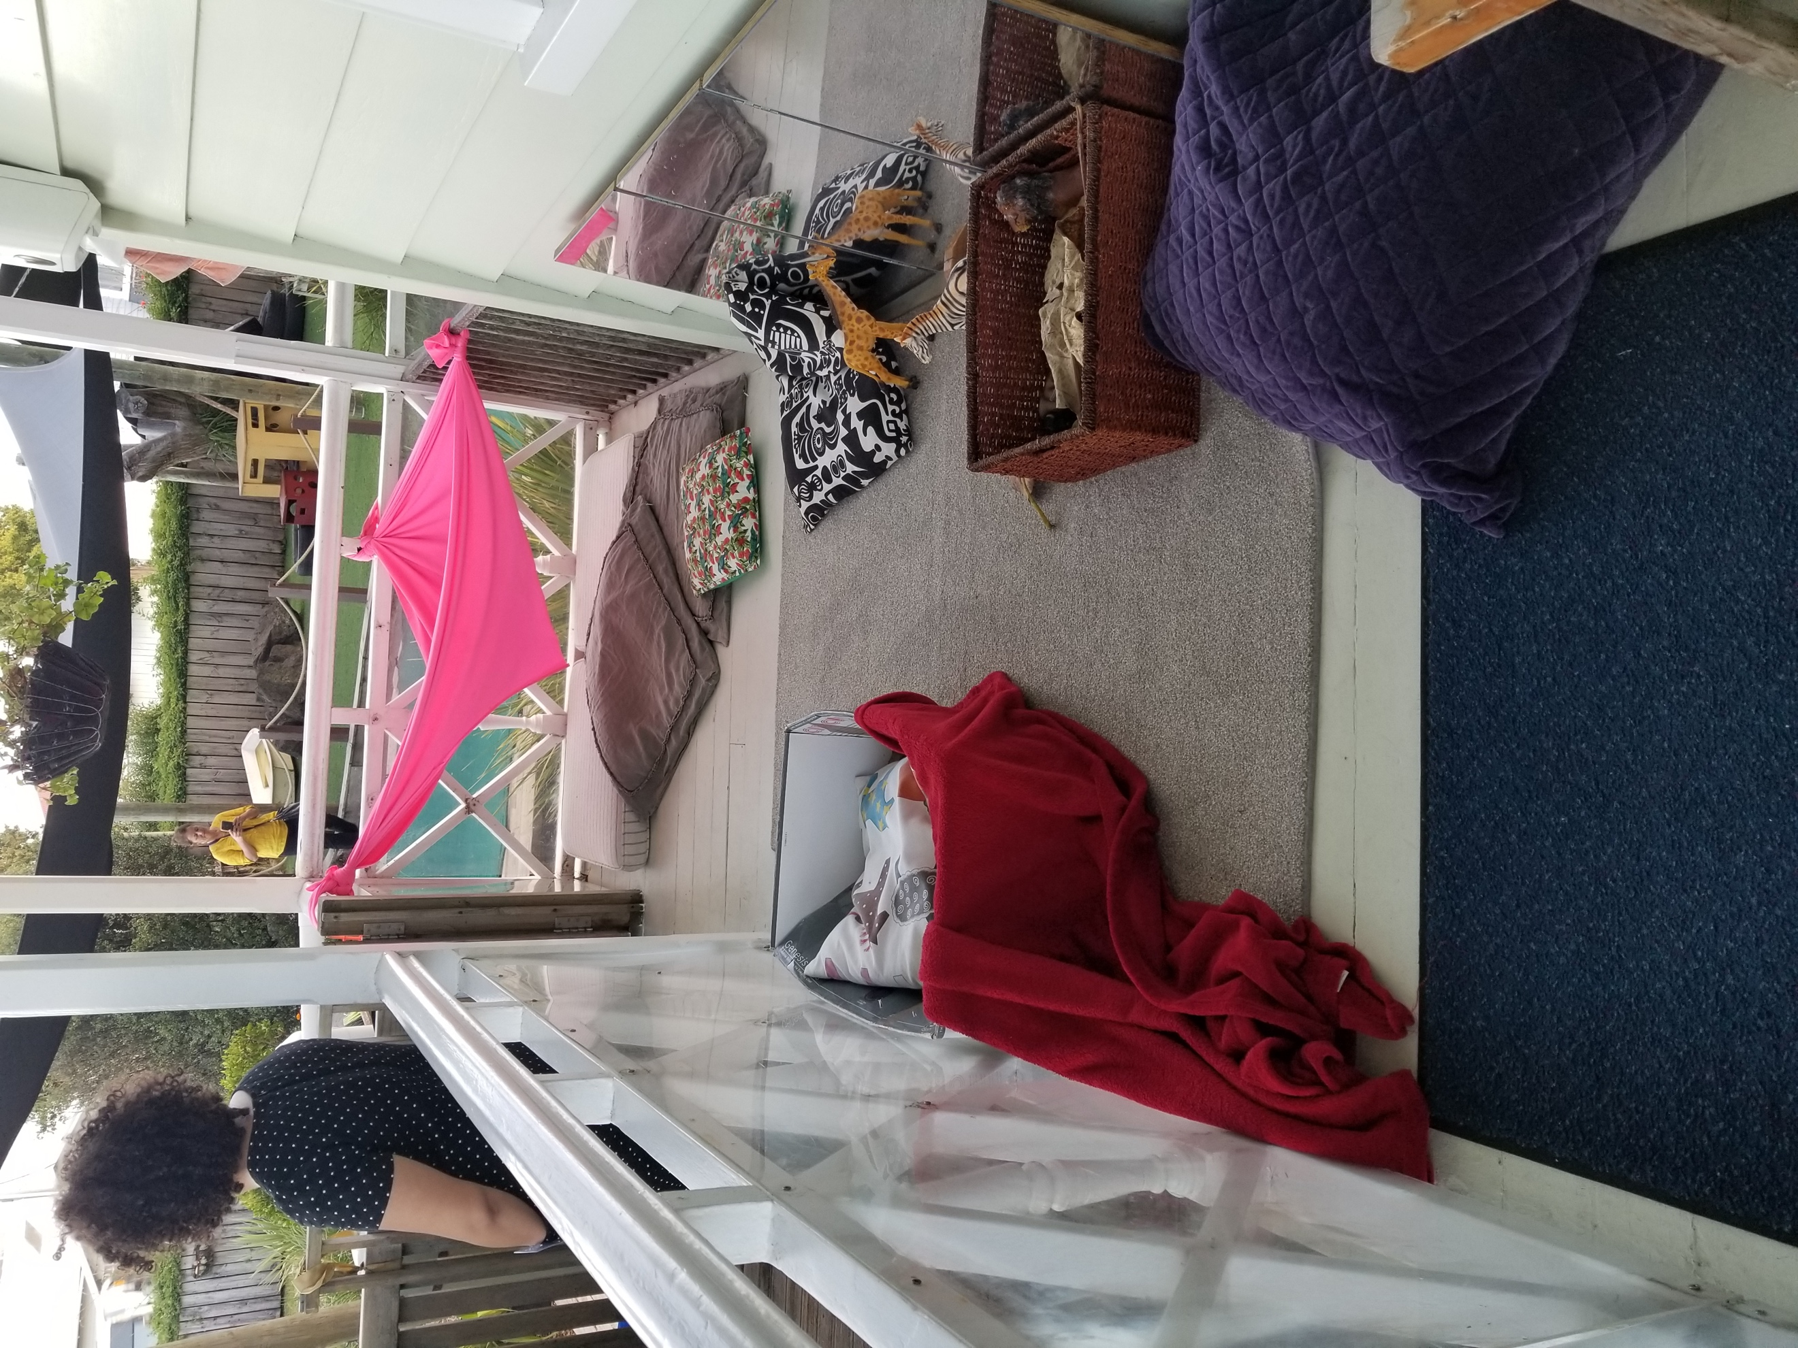

In the movie theater project: We were moved by how you gave children the option to use real hardware from the center to make their soda pump. We also noticed how you helped different groups of children break the project into different parts – art, dramatic play, mechanical design, writing – to allow unique learners to make the project their own.
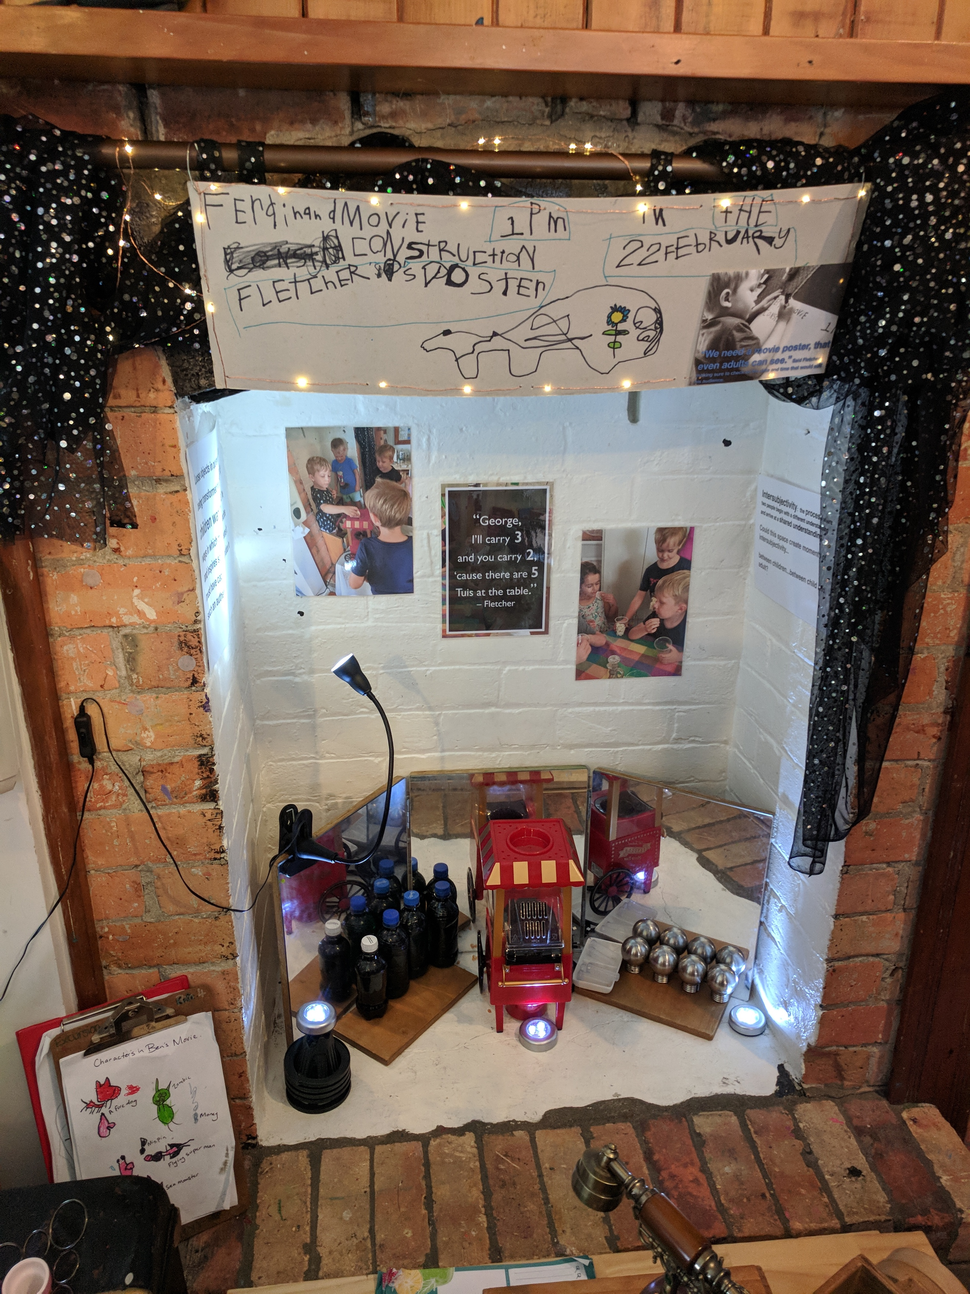
Through all these reflective moments, we were reminded of something Brenda Soutar said at the start of our week: “Everyone stays within the big picture and in consensus.” We are grateful to have seen so many clear signs that the Tots Corner teachers’ big picture centers around honoring and respecting children’s thinking and creativity.
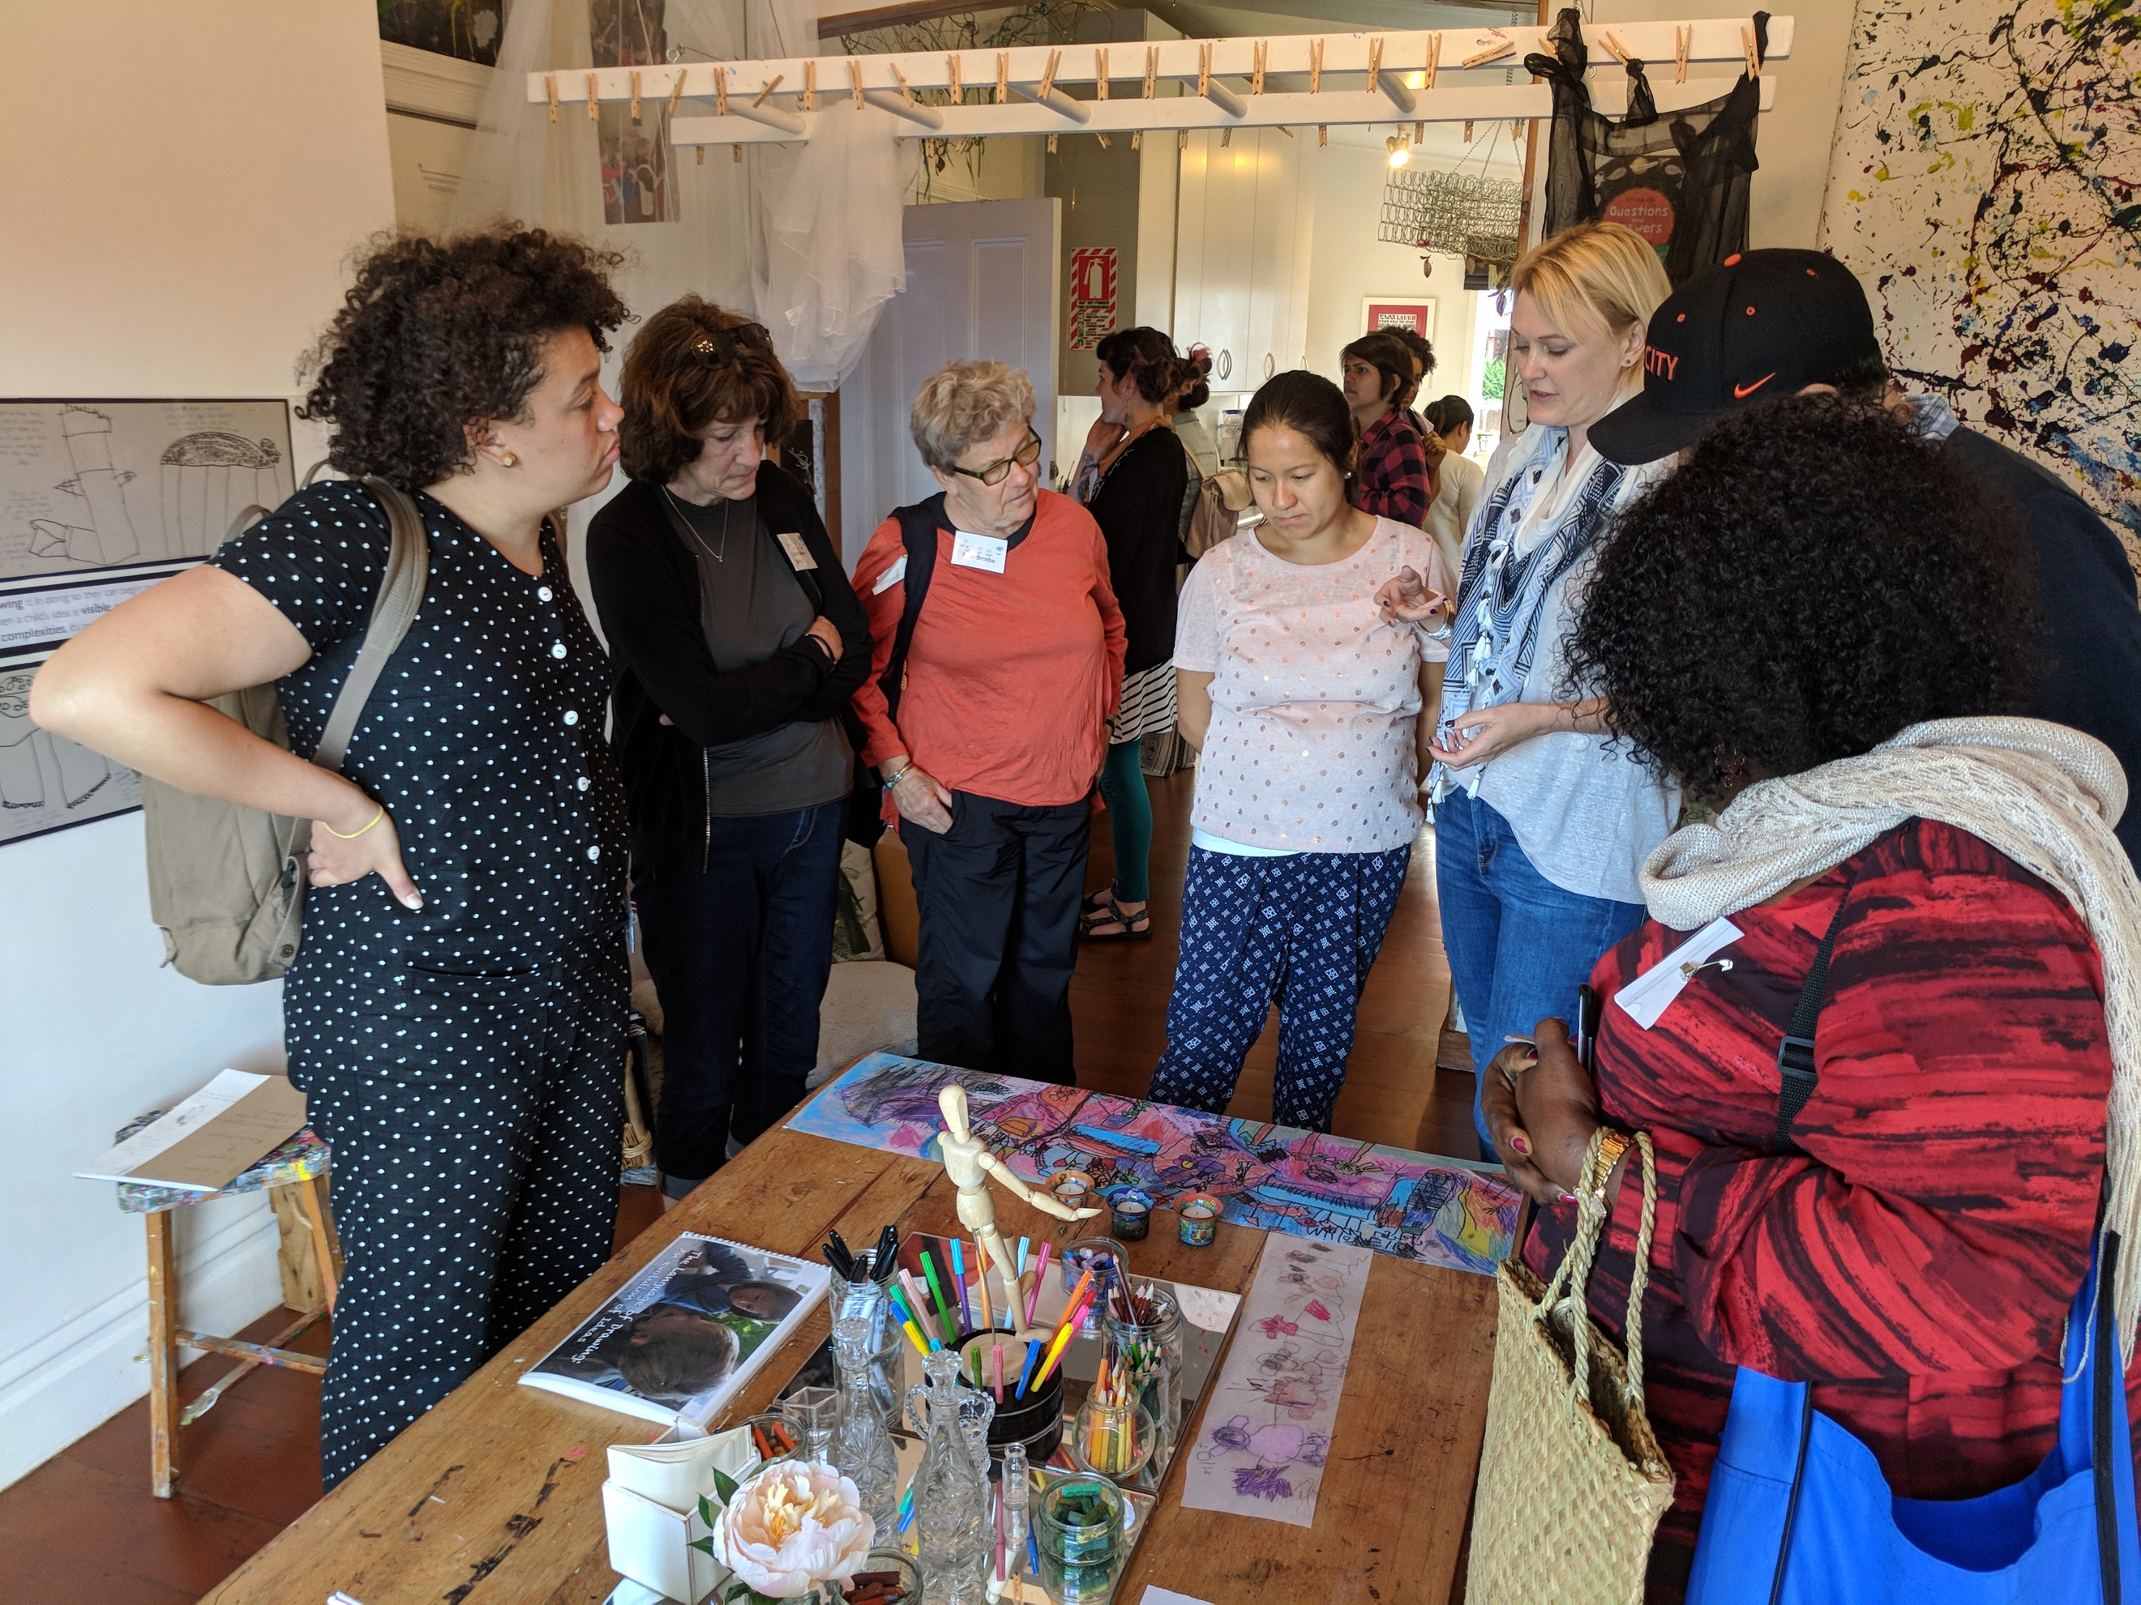

Thank you!
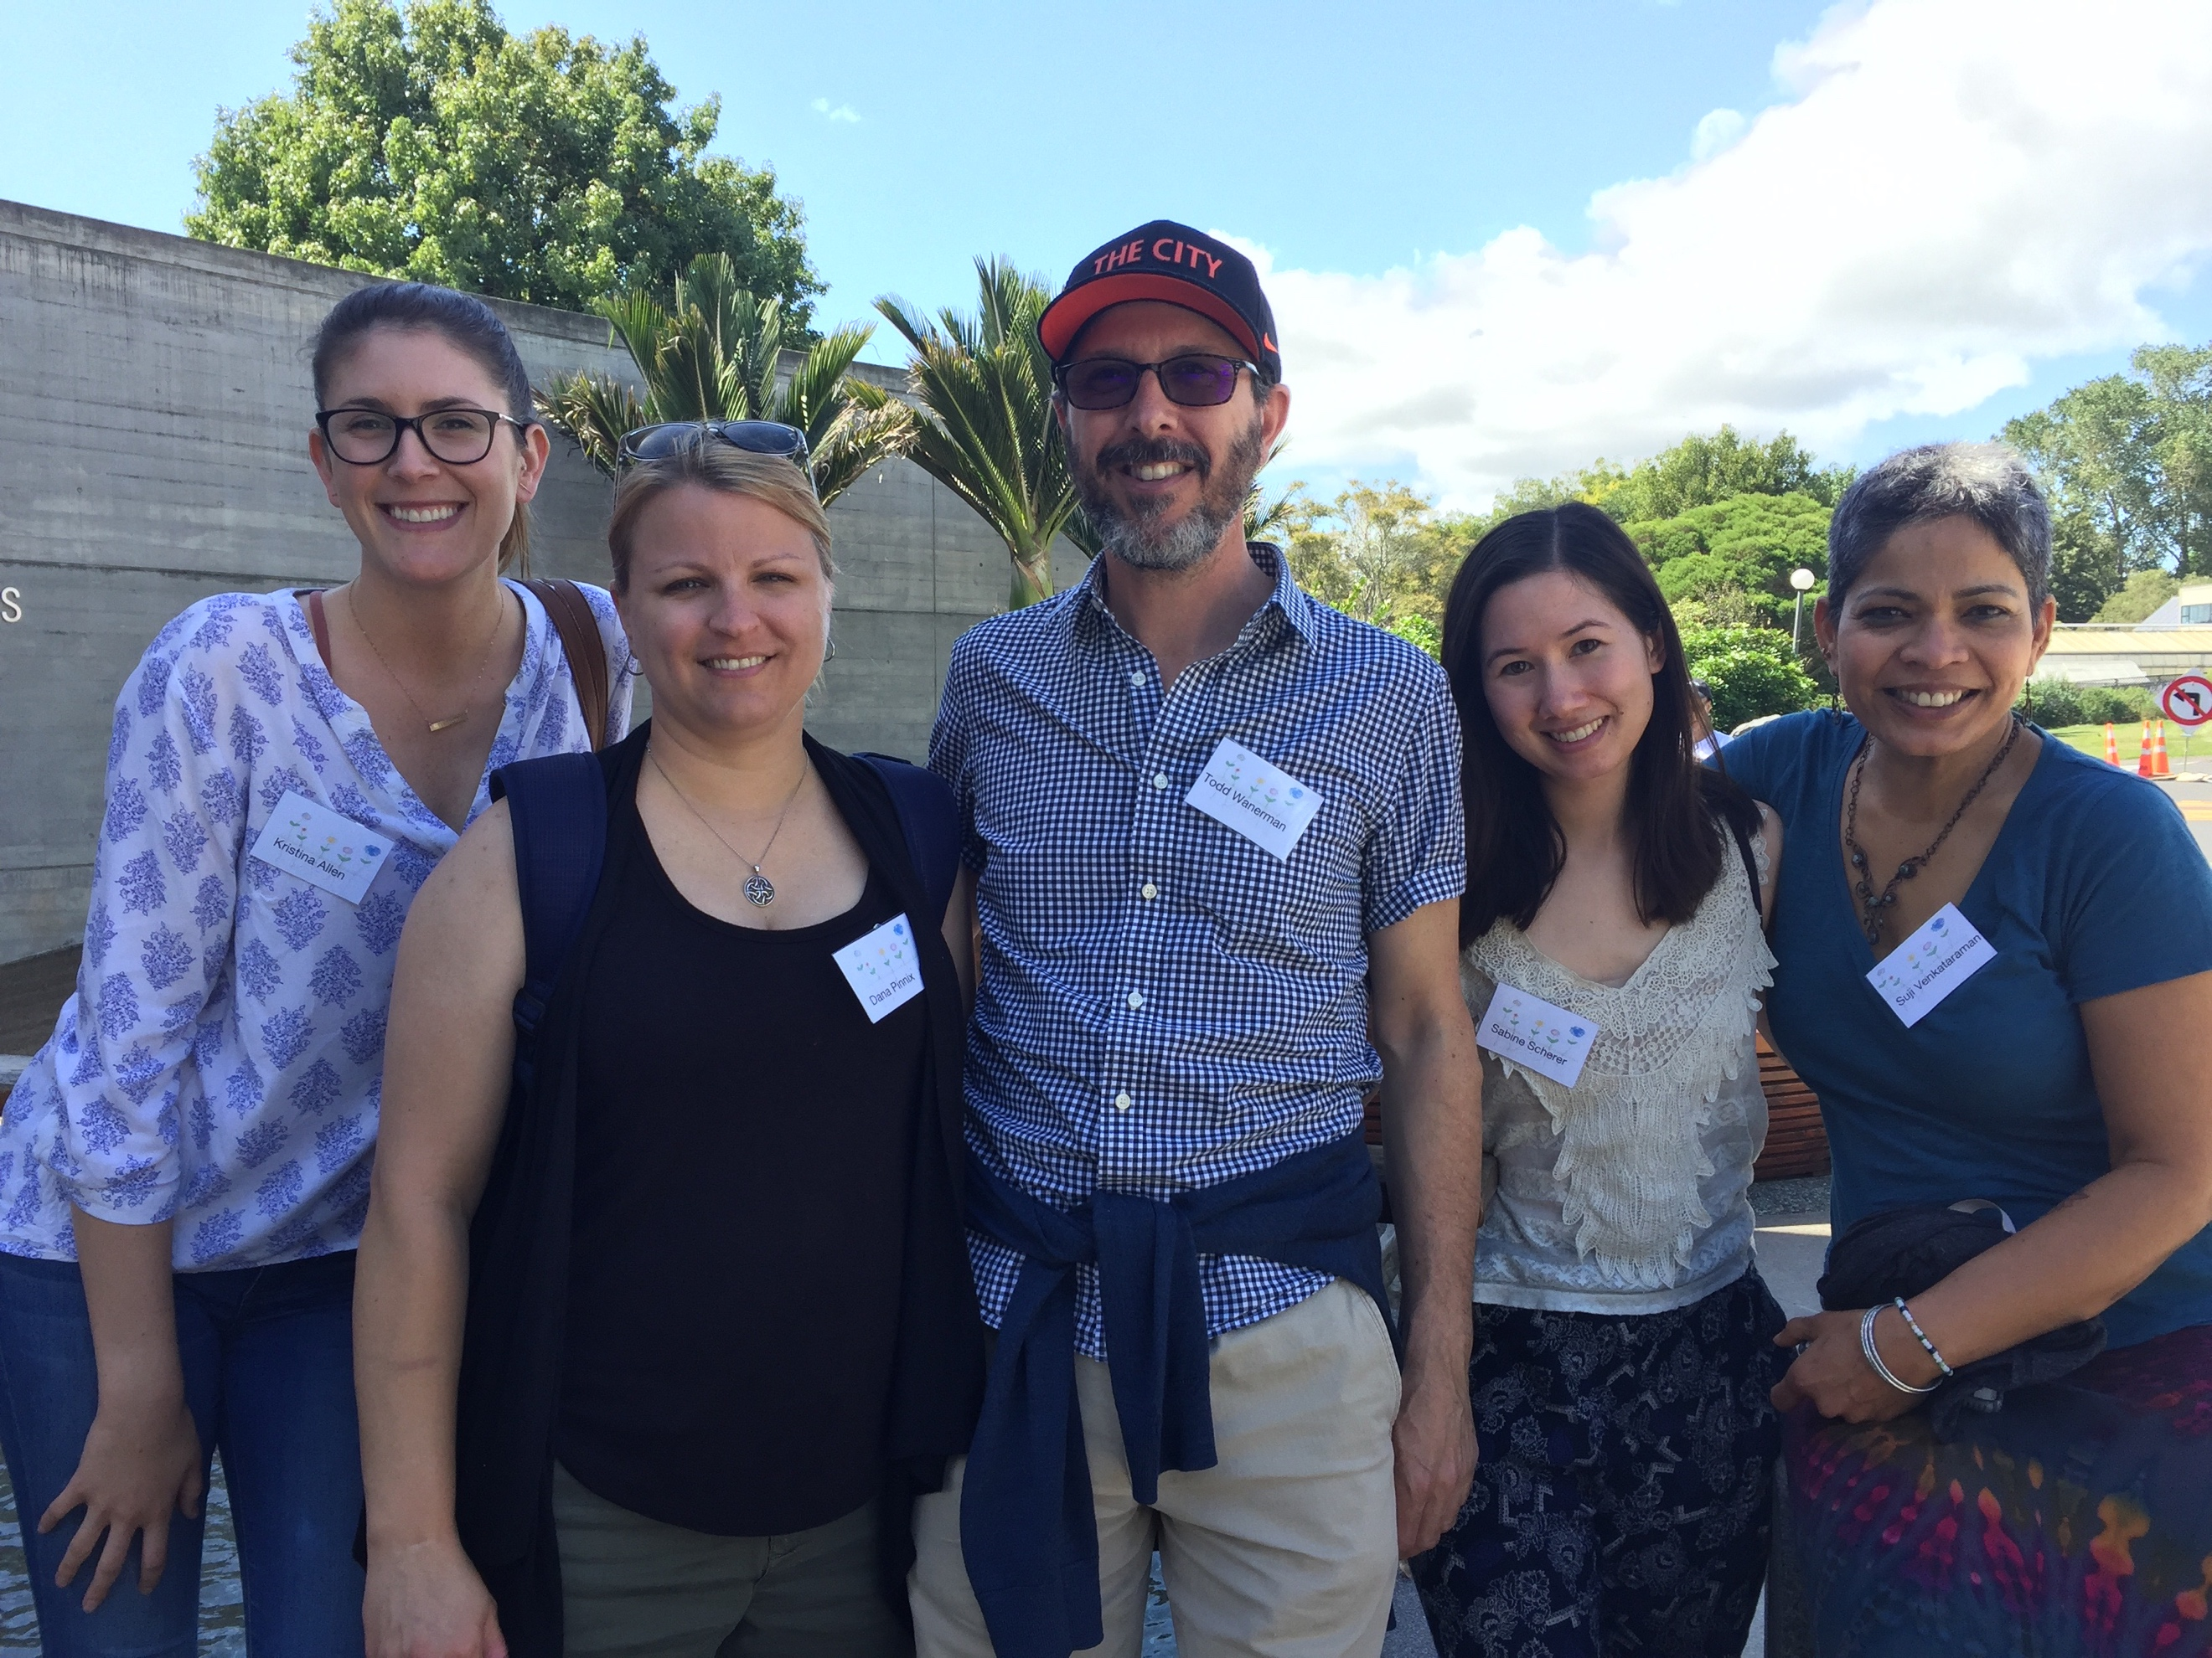
Kristina, Dana, Todd, Sabine and Suji

